References

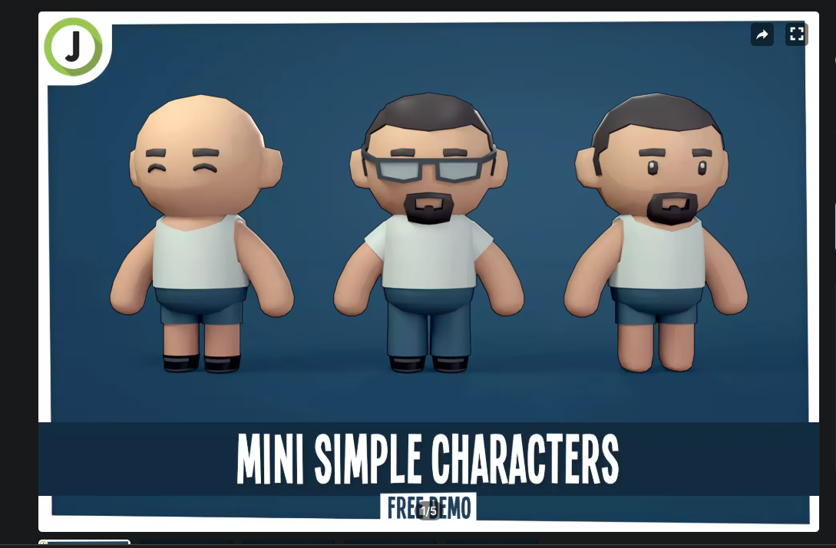
Baltieri, J., 2023. Mini Simple Characters | Free Demo. Available at: https://assetstore.unity.com/packages/3d/characters/humanoids/mini-simple-characters-free-demo-262799 [Accessed 1 April 2025].

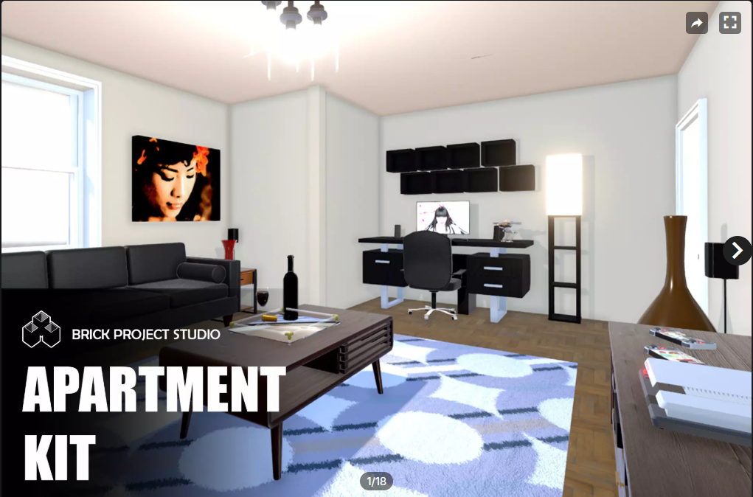
Brick Project Studio, 2023. Apartment Kit. Available at: https://assetstore.unity.com/packages/3d/environments/apartment-kit-124055 [Accessed 26 March 2025].
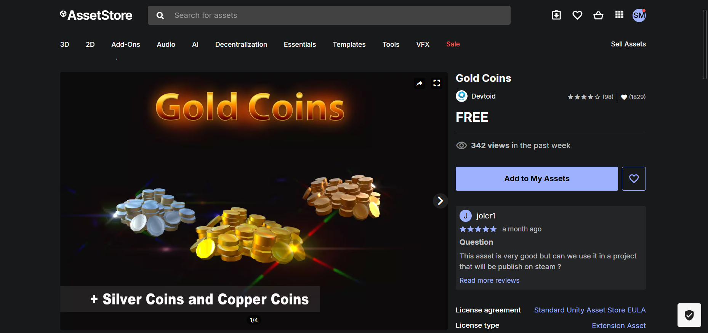

Devtoid, 2019. Gold Coins. Available at: https://assetstore.unity.com/packages/3d/props/gold-coins-1810 [Accessed 2 April 2025].

Dredstudio. 2025. Background (Online). Available at: https://dredstudio.com/background/ [Accessed 3 April 2025].

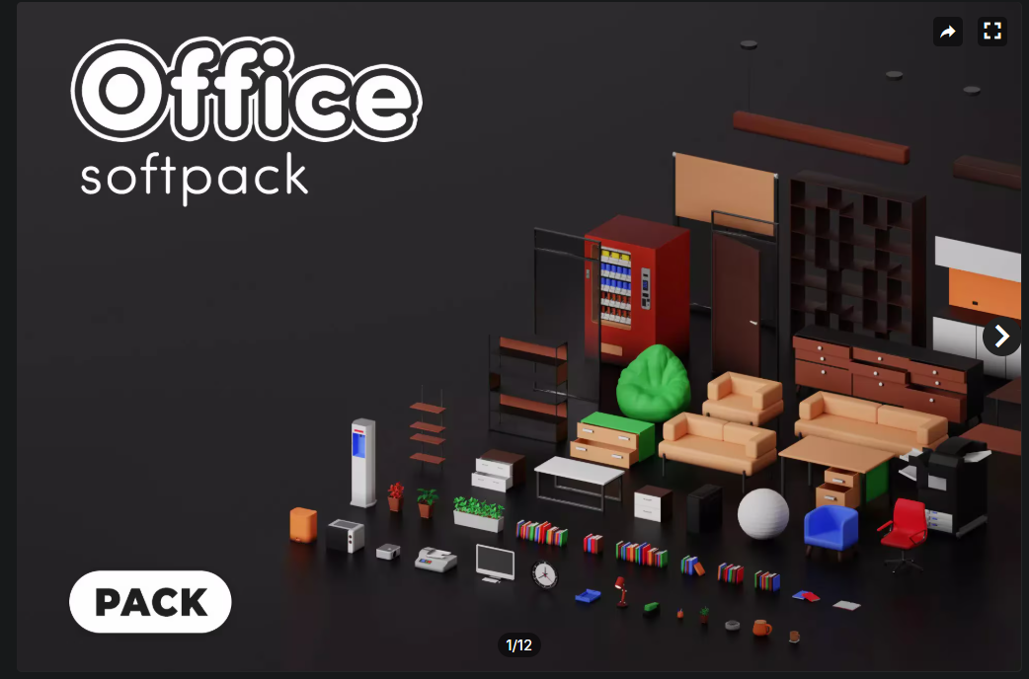
MeshStudy, 2023. Office Pack – Free. Available at: https://assetstore.unity.com/packages/3d/props/interior/office-pack-free-258600 [Accessed 3 April 2025].

Doshrosity, 2022. 32×32 Health UI [online]. Available at: https://doshrosity.itch.io/32x32-health-ui [Accessed 23 June 2025].

Pixaby, 2024. Video Game Boss Fiight. [online].Available at: https://pixabay.com/music/upbeat-video-game-boss-fiight-259885/ [Accessed 23 June 2025].

MadFireOn, 2020. Hyper Casual UI – Free [Game asset].[online]. Available at: https://swapnilrane24.itch.io/hyper-casual-ui-free [Accessed 23 June 2025].

TibaSFX, 2024. Woosh. [online].Available at: https://elements.envato.com/woosh-DB6WKRP [Accessed 23 June 2025].

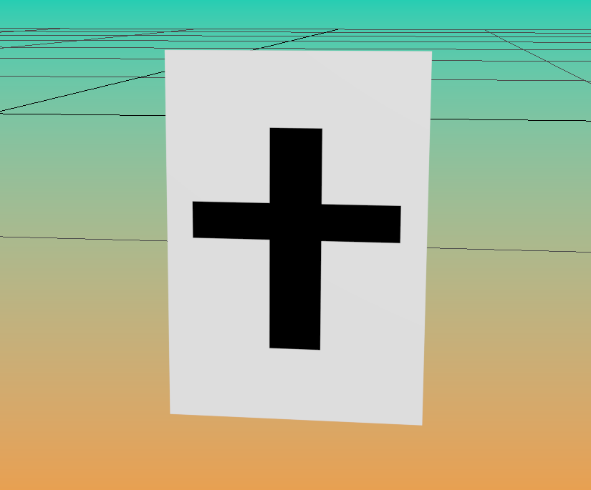
Mokoena, S., 2025.Design for GADE game [Image of Extra life Token]. Johannesburg: Unpublished.

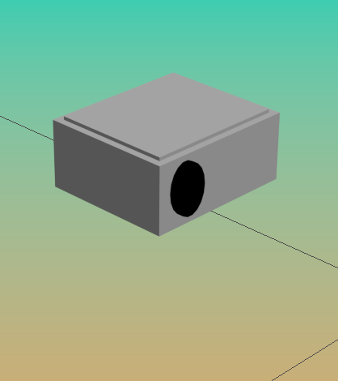
Mokoena, S., 2025.Design for GADE game [Image of Projecter asset]. Johannesburg: Unpublished.

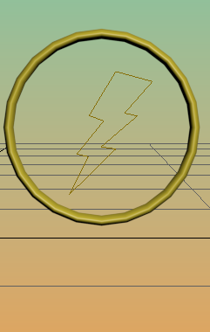
Mokoena, S., 2025.Design for GADE game [Image of Speed boost Token]. Johannesburg: Unpublished.

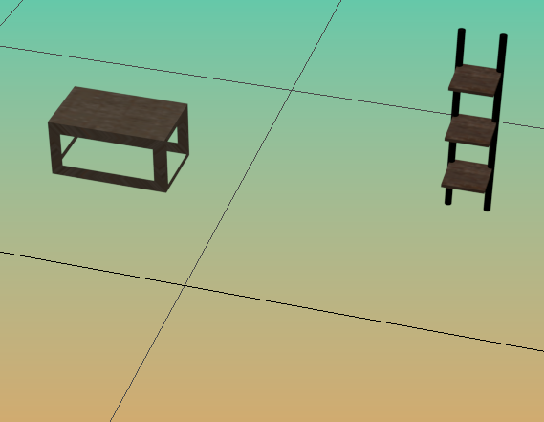
Mokoena, S., 2025.Design for GADE game [Image of office equipment]. Johannesburg: Unpublished.

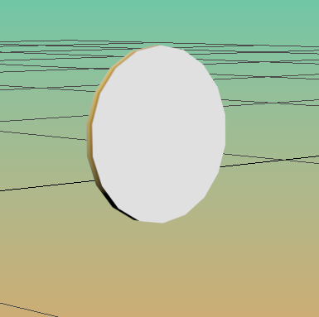
Mokoena, S., 2025.Design for GADE game [Image of coin Token]. Johannesburg: Unpublished.

